# Receipt Processing

Receipt processing lets you read and save key information from common sales receipts, such as receipts that are used in restaurants, gas stations, retail, and more.

# Create an app by using receipt processing

Receipt processing uses a prebuilt AI model, which means that no prior training or configuration is required. You can use this model immediately in your canvas app by using the **Receipt processor** component.

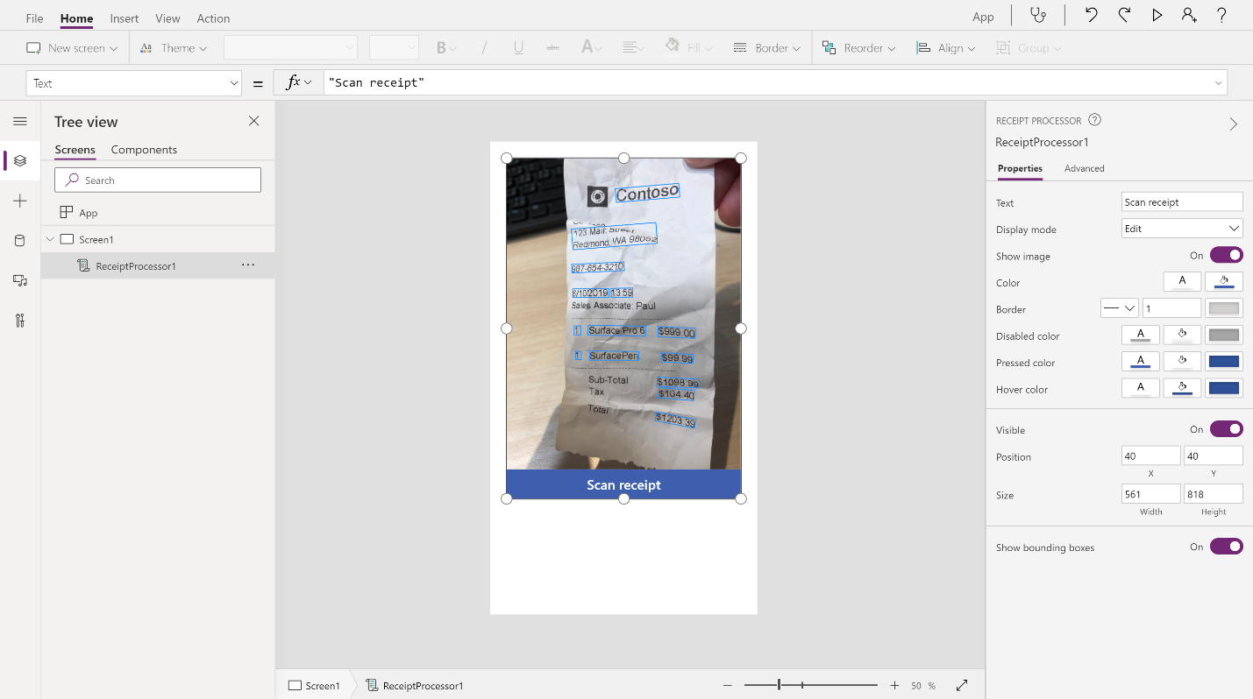

In this exercise, you will create an app that scans a receipt and then displays the extracted information.

### **Add the Receipt processor component**

To add the **Receipt processor** component to your app, follow these steps:

1. Sign in to Microsoft Power Apps Studio and open a new or existing canvas app.
2. Select **Insert > AI Builder** from the top menu.
3. Select **Receipt processor (preview)**.

[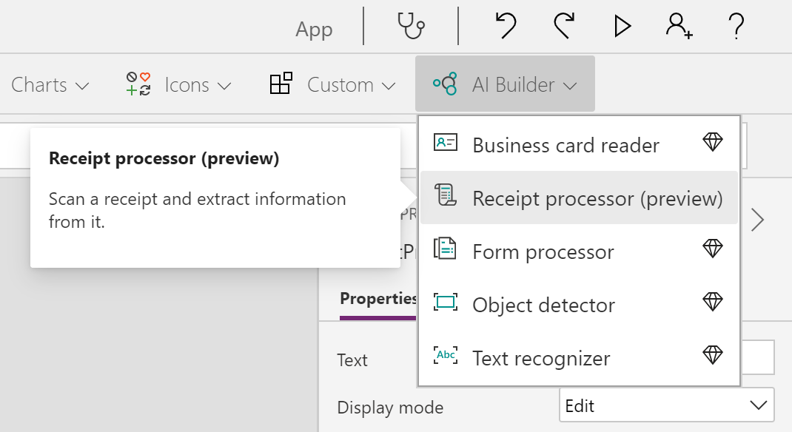](https://docs.microsoft.com/en-us/learn/modules/ai-builder-receipt-processing/media/3-2.png#lightbox)

Select the **Play** button in the upper-right corner of the screen to preview your app. You can then select the **Scan receipt** button on the component to upload a test image, which will scan and outline the key detected information from the receipt.

### **Use scanned information**

The AI model will look for the most commonly used fields in receipts. The values of these fields can be retrieved directly as properties from the component.

1. Select **Insert > Label**.
2. After you have selected the newly created label component, set its **Text** property by using the formula bar to the **Total** property of the **Receipt processor** component.

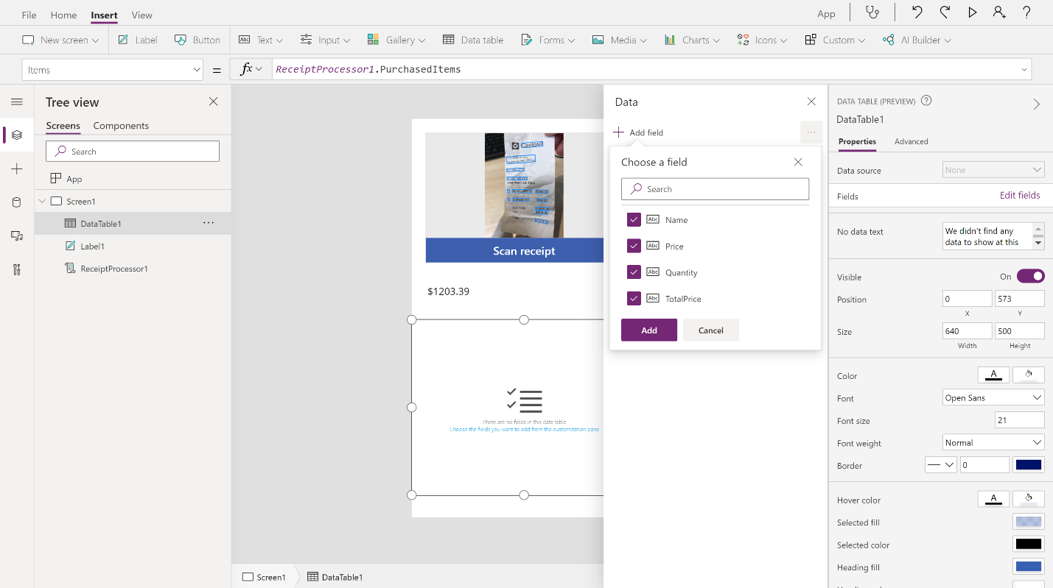

1. Select **Insert > Data table**.
2. After you have selected the newly created data label component, set its **Items** property by using the formula bar to the **PurchasedItems** property of the **Receipt processor** component.
3. In the Properties pane of the data label component, select **Edit fields**.
4. Select the **Add field** button.
5. Select all field options and then select **Add**.

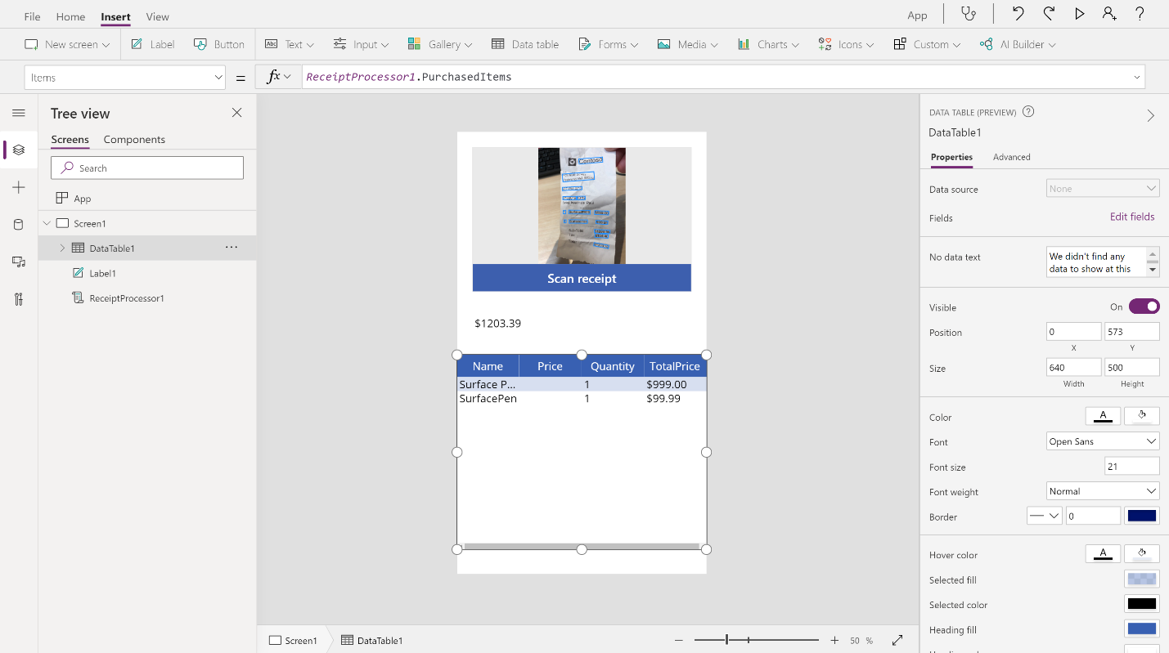

You can retrieve additional information about your receipts by using the **DetectedFields** and **DetectedText** properties.

**DetectedText** contains a raw list of all recognized lines of text on the receipt.

**DetectedFields** contains advanced information about the key fields, such as the confidence score, bounding box, and page number.

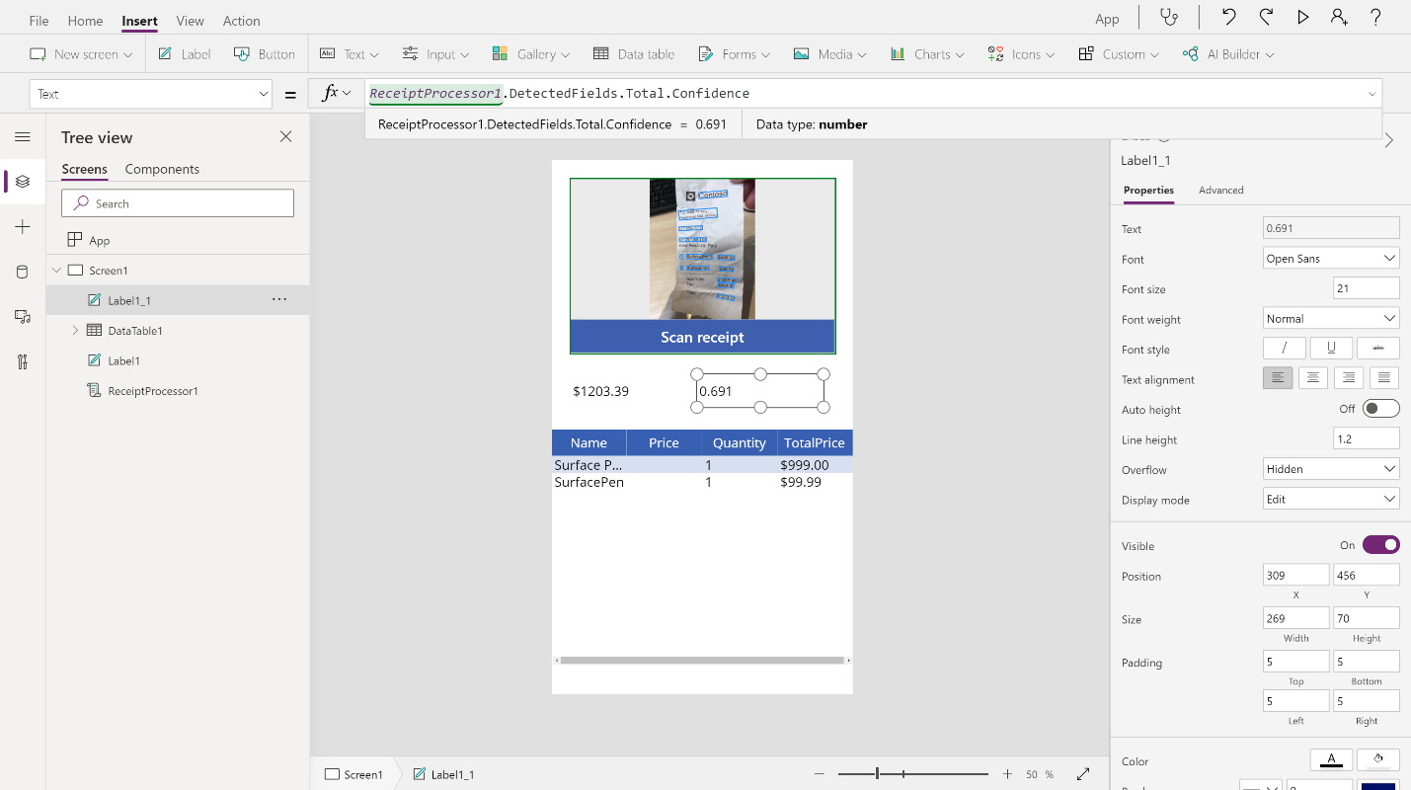

For instance, to show the confidence score for the **Total** field that you displayed earlier, follow the next two steps.

1. Select **Insert > Label**.
2. After you have selected the newly created label component, set its **Text** property by using the formula bar to the **DetectedFields.Total.Confidence** property of the **Receipt processor** component.